**ECE 643 Final Project Weekly Progress and Goals Fall 2021**

This form is due by 11:59pm Friday of each week. Submit at Canvas.

Name(s): Cesar Zavala, Anthony Garvalena, Cody Morse

Date/week: 10/29/21 – Week 1

You are encouraged to use bullets or lists for each of the 3 items below.

**Goals from the past week:**

* Complete Proposal Document
* Get GSensor Tetris Project Approved

**Status on prior week’s goals:**

* Completed Proposal Document
* Project was approved

Extras:

* + Worked on project setup and got the play area to have our score, line count, level, and grid border. Additionally, we have coded our program to give us the exact pixel location based on the grid location. We will be making tweaks over the weekend.

**Goals for the next week:**

* State Machine & State Diagram
* GUI Design
* Tetromino Rotation
* Basic Game Logic
* Basic Motion Controls

**VGA Output:**

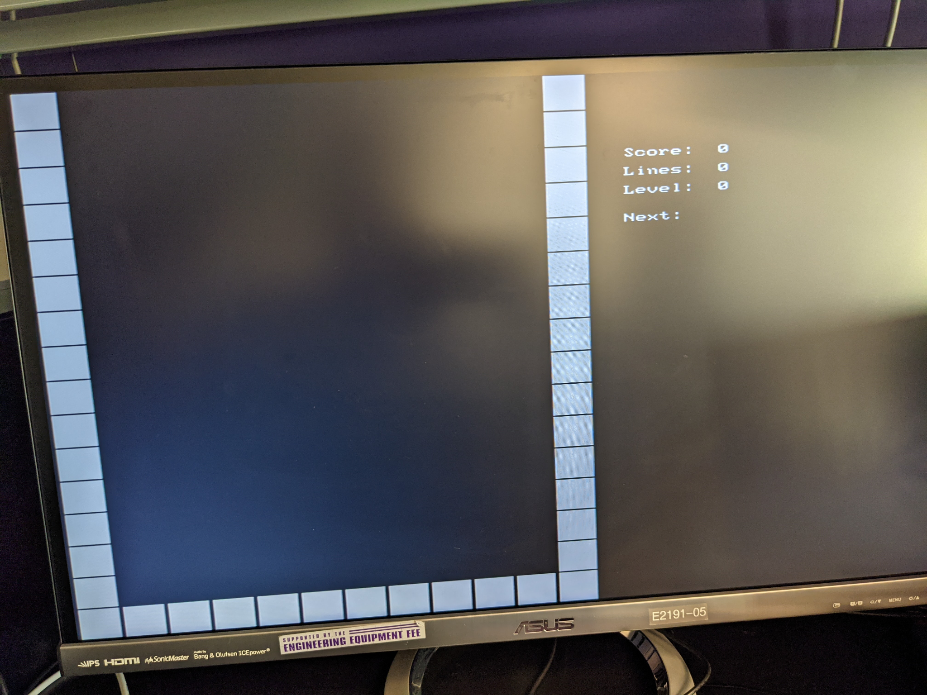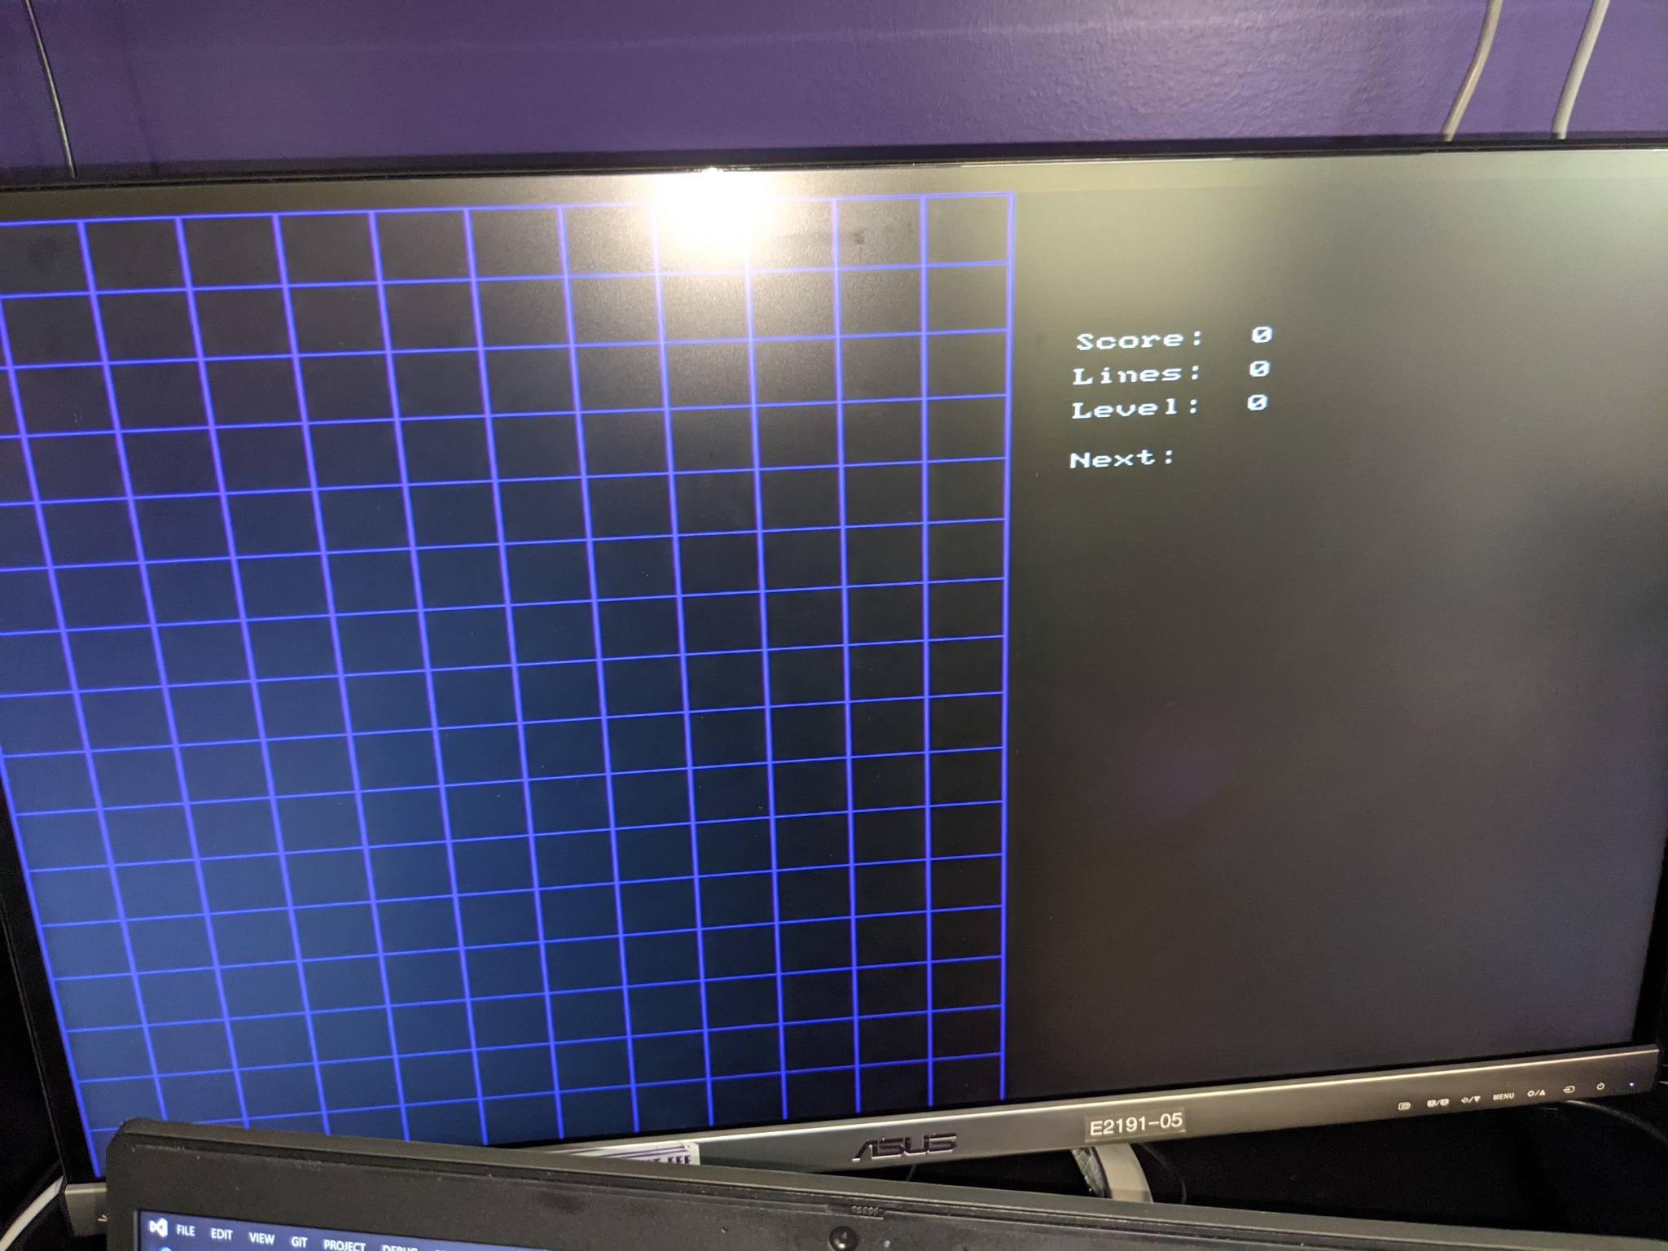

**Code:**

